Chapter 3 Design

3.1 Design Introduction
Designing is the process of drawing pattern of the system functionality before the system is made. Designing is done after analyzing the project features and function. Designing helps to converts the requirements of user and system into the suitable form which help the developer in coding.

Structural diagram

3.2.1 Class diagram
Class diagram is the static diagram that represents the static view of the system. It also describe the attributes and operations of classes.
- Justification
I have selected class diagram for this project as it shows the proper design of the system efficiently. As our project is object oriented, class diagram is best for this as it is based on the object oriented principle. It also helps to model the software. It also shows the relation between the classes and shows how the classes of the system interact with one another before writing code.

Optional diagram (Flow chart diagram)
Flow chart is the graphical representation of steps of the system. It also one of the powerful tool used in business. Flowchart uses many shapes which can be defined as steps which are connected with arrows to represent the flow and sequence of the system.
- Justification
I have chosen flow chart diagram as optional diagram for this project. I have selected flow chart as it is the most powerful business tool. Flow chart with proper and clear drawing helps to communicated with the process more effectively and efficiently.
- Notation
Notation / Symbol | Name | Reason
 | Flow line | Shows the process order. It joins the two symbols.
 | Terminator | The terminator symbol represents the starting or ending point of the system.
 | Process | This represent the process or operation that change the value. Represented by rectangle shape.
 | Decision | Represented by diamond shape. It indicated different possible situation, leading to different sub-process.
 | Input/ Output | It represents the entering or leaving from the system.
 | On-page connector | Circle helps in replacing the confusing lines of flowchart.

- Diagram
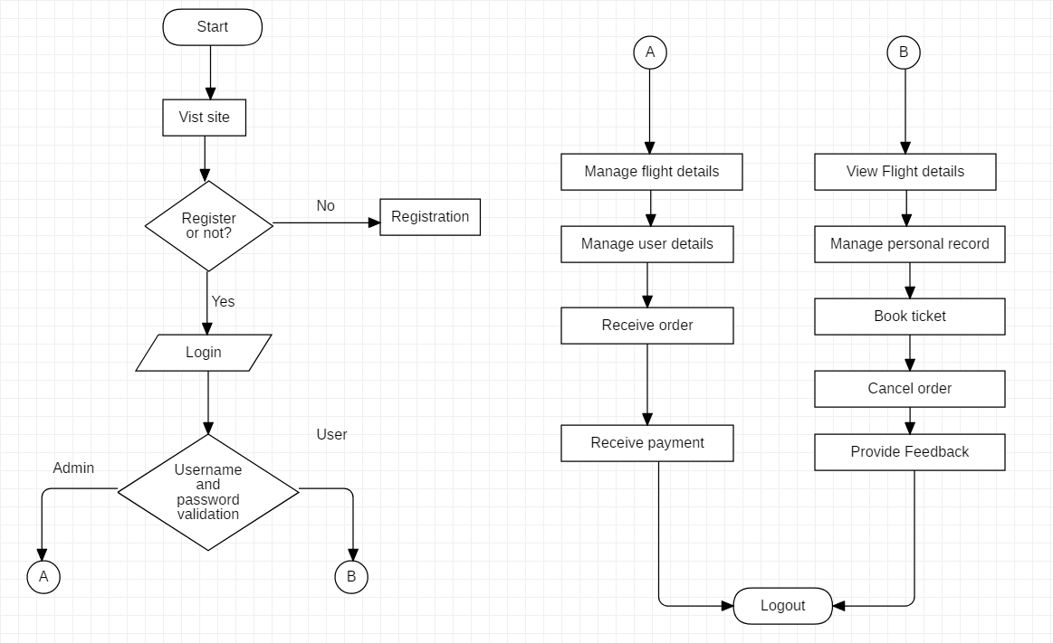
Figure 1: Flow chart

Figure (1) represents the flow of system where the login and registration process is shown. Both admin and user should be logged in to get access to the system. Admin is allowed to manage flight details and user details, can receive order of ticket. Similarly, user are allowed to view the details of flights, can book the flight ticket and pay for the flight.

3.3 Behavioral Diagram

Activity Diagram
Activity diagram is the graphical representation of the features of the software. It is an advanced form of flowchart that model the operation from one activity to another. Activity diagram is construct using number of shapes connected with arrow.
- Justification
For the behavioral diagram, I have chosen activity diagram for this project as it the dynamic structure of stepwise action and activities. It also show the flow of data between activities.
- Notation
Notation / Symbol | Name | Reason
 | Start point | It shows the initial phase of the workflow.
 | Activity state | It represents the non-interruptible action of the object. It has shape of rectangle with round corners.
 | Action flow | It represents the transitions of one action state to another one.
 | Decision | It represent a decisions with alternate paths. Represented by diamond shape.
 | Final state | It shows the final phase of the workflow.
 | Sent symbols | It represent the signal is being sent to receive symbol.
 | Receive symbols | It represent the signal is being received from sent symbol.
 | Time event | Hour glass shape represent to an event that stops the flow of time.
 | Fork Node | Splits the behavior into a set of parallel or concurrent flows of activities.
 | Join node | Bring back together a set of parallel or concurrent flow of activities.
 | Note | It is used for adding additional remarks.

- Diagram
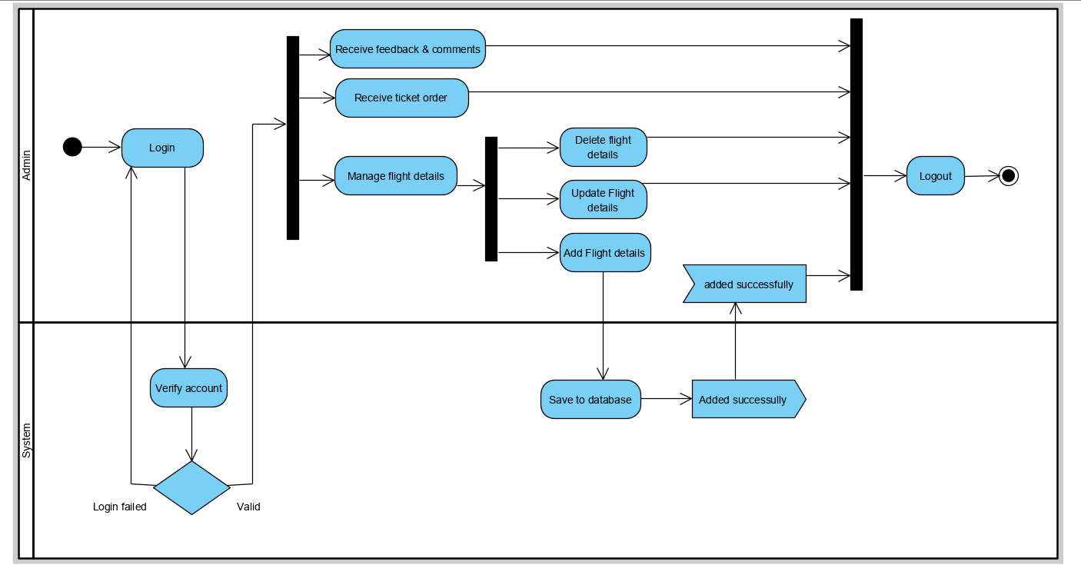
Figure 7: Activity diagram of admin
Above diagram show the full method of the use of system by admin. First the admin must be logged into the system. Admin can add new details of flight and also can update or edit the flight record. Admin is responsible for deleting the flight record after departure of flight. Admin can also manage the user record and also receive the feedback send by the user. Admin will also be able to view the booking of flight.

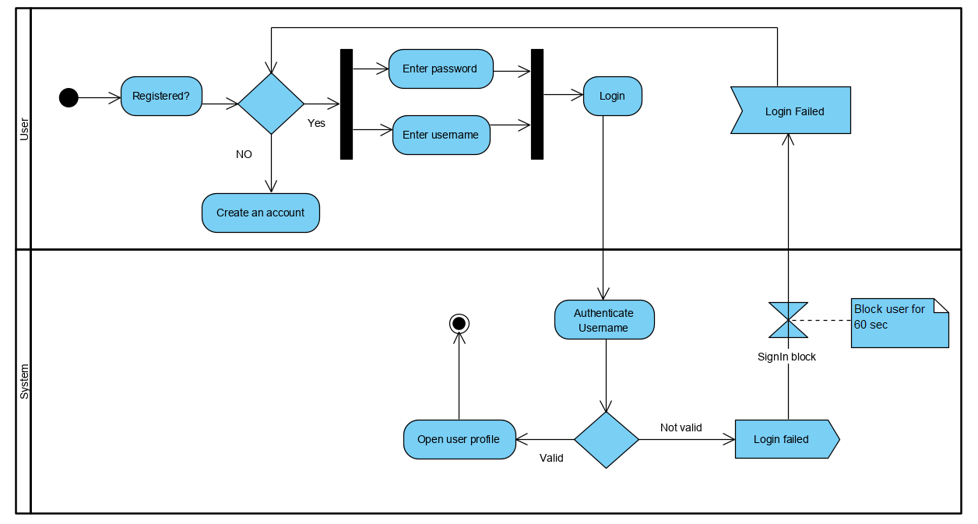
Figure 8: Activity diagram of user login
This figure show the login system of the user. First the user must be registered to the system if the user is new to the system or they can be directly logged in to the system. After the 3rd attempt of login user will be blocked for 5minute.
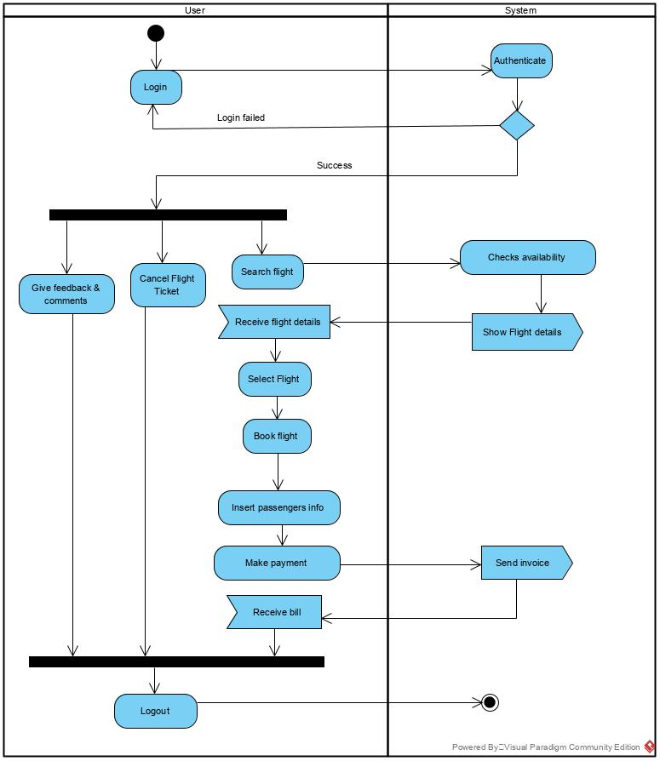
Figure 9: Activity diagram for user
Above figure show the workflow of process done by user. User access to the system can view the flight record and can book the flight according to their destination. User can also cancel the flight ticket after booking the flight. User can give their feedback regarding the system.

Sequence diagram
Sequence diagram defines the interaction between object in sequential order. Sequence diagram focus on time. It defines the event sequences between the objects. It can also be known as timing diagram or event scenario. (Anon., n.d.)
- Justification
I have chosen sequence diagram for my project because it show the interactive between the active objects. It represents the objects and classes of the system. It also helps to show the sequence of message sent between objects. It allows to discuss the design in concrete term. Sequence diagram is also useful for identifying the architectural, interface and logical problem early.
- Notation
Notation / Symbol | Name | Reason
 | Actor | It is a role played by the entity who interact with the system.
 | Activation box | It represents the period during which an element is performing an operation.
 | Object symbol | It represent the instances of class.
 | Lifeline | It represent each instance in an interaction.
 | Loop Symbol | It is used when the scenario occurs only under certain circumstances.
 | Alternative symbol | It is used to represents alternatives. Dash line is drawn inside the rectangle box.
 | Synchronous message | It is used when sender must wait for the response to the message.
 | Reply message | Dash line with arrow heads which replies to the calls.
 | Note | Used to attach additional remarks to elements.
 | Self-message | It represents the invocation of message of the same lifetime.

- Diagrams
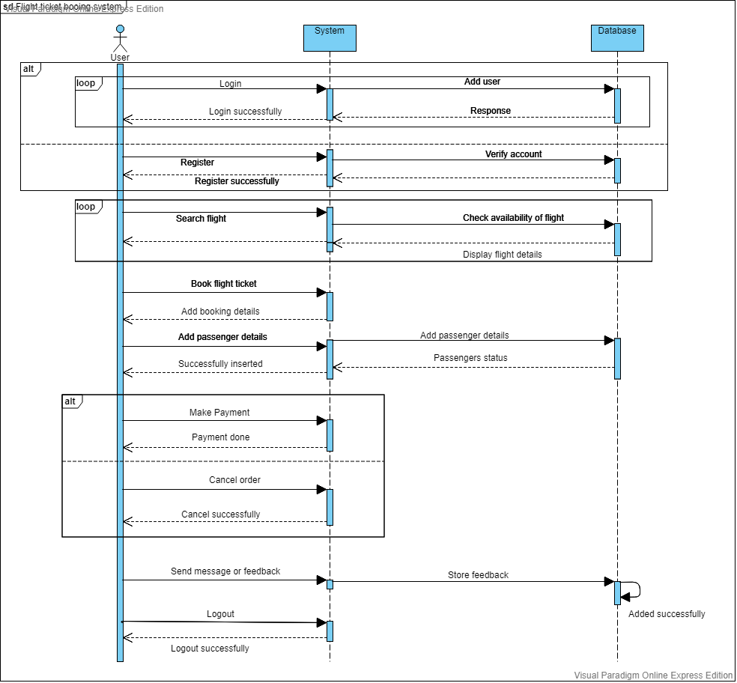
Figure 10: Sequence diagram for user

Above diagram is the sequential diagram for the user. User should be register to get access to the system and user details will be save in the database. After the getting access to the system, user will be able to search the flight, book flight ticket and will be able to make payment. User can also cancel the order according to their will.

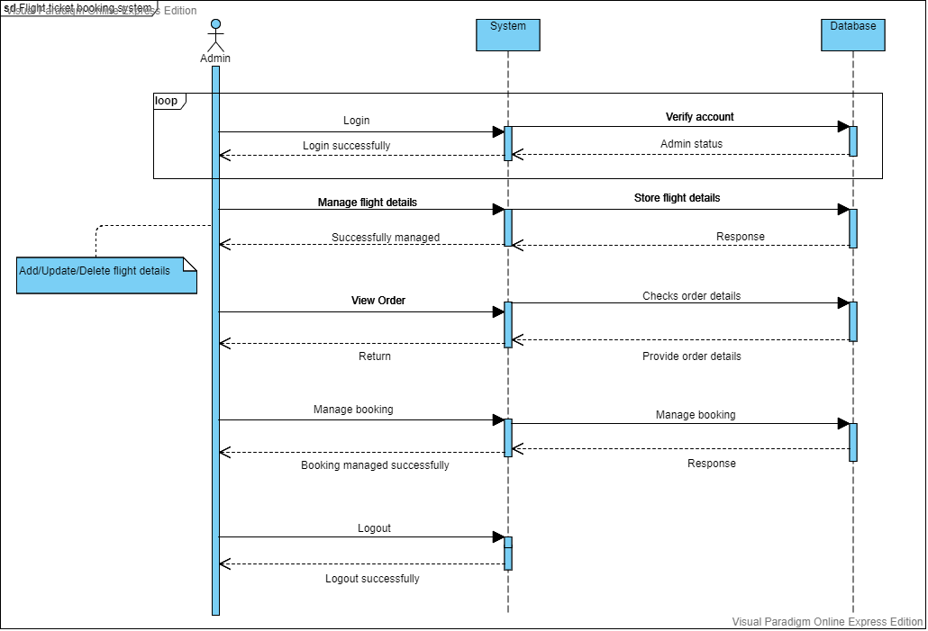
Figure 11: Sequence diagram for admin
In this figure, login process of admin is shown. Admin must be signed in to the system to get access to the admin panel. Admin can view the ticket order, manage the flight record, manage the user, and also receive payment of the ticket.

3.4 Database Modeling

3.4.1 Data dictionary
- User Registration Table
No. | Attribute | Data Type | Length | Constraint | Description
1 | Reg_id | Integer |  | Primary key | It store registration id.
2 | Fname | Varchar | 30 | Not Null | It store user first name.
3 | Lname | varchar | 30 | Not Null | It store user last name.
4 | Username | varchar | 30 | Not Null | It store username of user.
5 | Email | varchar | 50 | Not Null | It store email of user.
6 | Password | varchar | 20 | Not Null | It store user password.
7 | Confirm Password | varchar | 20 | Not Null | It store confirm password.

- User Login Table
No. | Attribute | Data Type | Length | Constraint | Description
1 | Userid | Integer |  | Primary key | It store User id.
2 | Username | varchar | 30 | Not Null | It store username of user.
3 | Password | varchar | 20 | Not Null | It store user password.

- Admin Login Table
No. | Attribute | Data Type | Length | Constraint | Description
1 | Adminid | Integer |  | Primary key | It store Admin id.
2 | Username | varchar | 30 | Not Null | It store username of admin.
3 | Password | varchar | 20 | Not Null | It store admin password.

- Flight details table
No. | Attribute | Data Type | Length | Constraint | Description
1 | Flight_id | Integer |  | Primary key | It store Flight id.
2 | Flight_code | varchar | 30 | Not Null | It store Flight code.
3 | From | varchar | 30 | Not Null | It store passenger arrival place.
4 | Destination | varchar | 30 | Not Null | It store flight destination.
5 | Fare | varchar | 50 | Not Null | It stores flight ticket price.
6 | Departure_time | varchar | 30 | Not Null | Store departure time of flight.
7 | Arrival_time | varchar | 30 | Not Null | Store arrival time of flight.
8 | Time | varchar | 50 | Not Null | It stores time taken to reach destination place.
9 | Date | date |  | Not Null | It stores traveling date.
10 | Adminid | Integer | 255 | Foreign key | It comes from admin table.

- Passengers details table
No. | Attribute | Data Type | Length | Constraint | Description
1 | Passenger_id | Integer |  | Primary key | It store Passengers id.
2 | No_of_ticket | Integer | 30 | Not Null | It store number of ticket.
3 | Name | varchar | 50 | Not Null | It store passengers' name.
4 | Address | varchar | 50 | Not Null | It store passengers address.
5 | Contact no | varchar | 30 | Not Null | It stores passengers contact number.
6 | No_of_passenger | Integer | 30 | Not Null | It store number of passengers in flight.
7 | Flight_id | Integer | 255 | Not Null | IT comes from flight table.

- Payment table
No. | Attribute | Data Type | Length | Constraint | Description
1 | Payment_id | Integer |  | Primary key | It store Payment id.
2 | Passenger_id | Integer |  | Foreign key | It comes from passenger table.
3 | Name | varchar | 30 | Not Null | It store card holder name.
4 | Postal_code | varchar | 20 | Not Null | It store postal code
5 | Card_type | Varchar | 30 | Not Null | It stores card type.
6 | Card_no | varchar | 100 | Not Null | It stores card number.
7 | Expiry_date | date |  | Not Null | It stores expiry date of card.

- Feedback Table
No. | Attribute | Data Type | Length | Constraint | Description
1 | F_id | Integer |  | Primary key | It store User id.
2 | Userid | Integer |  | Foreign key | It comes from user table.
3 | Username | varchar | 20 | Not Null | It store username.
4 | Date | date |  | Not Null | It stores date of given feedback.
5 | Message | varchar | 500 | Not Null | It store feedback.

3.4.2 ER Diagram
An entity relationship diagram is graphical representation of showing data relationships in software. It also works as a data modeling strategies that graphically shows the entities of information of systems and relation between those entities. (Kevin Ferguson, n.d.)
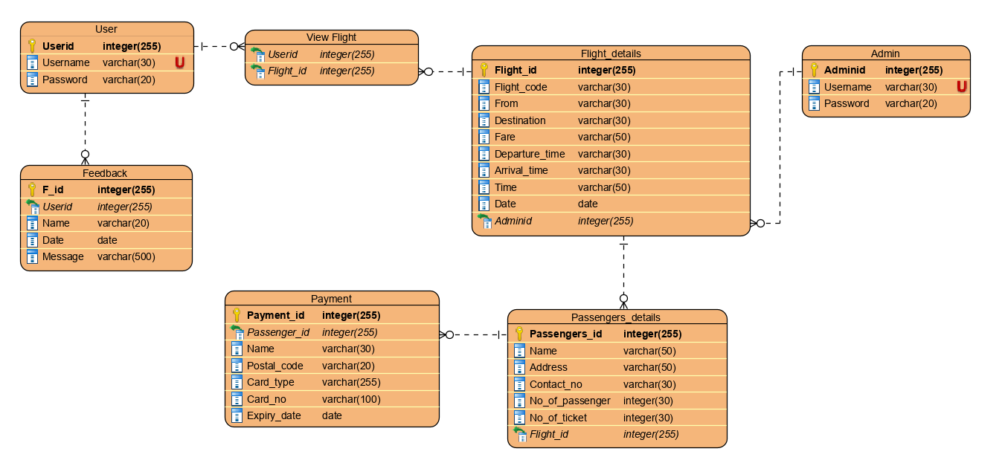
Figure 12: ER diagram

3.5 UI Modelling

- User login form

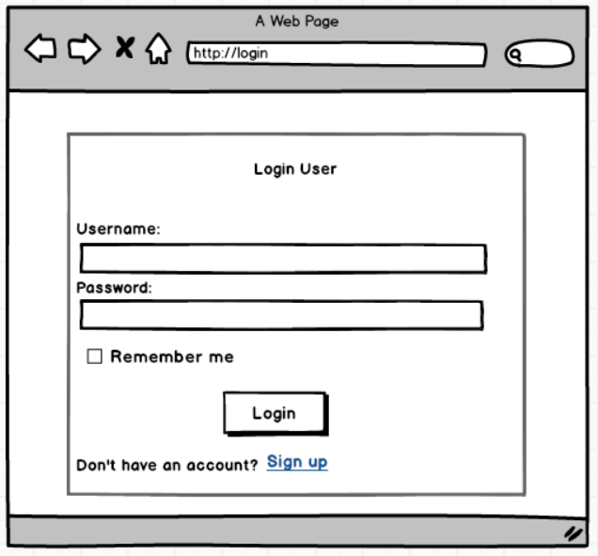
Figure 13: User login

- Registration form
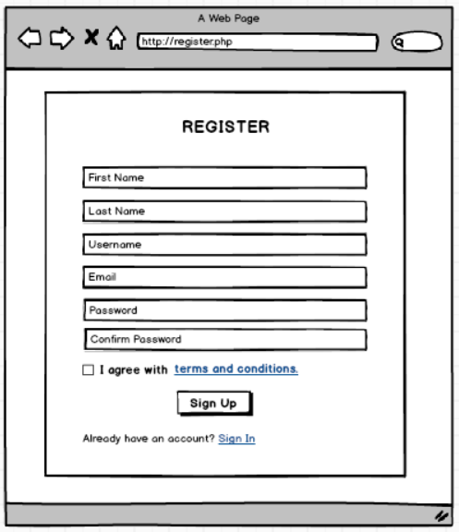
Figure 14: Registration

- View train details for booking
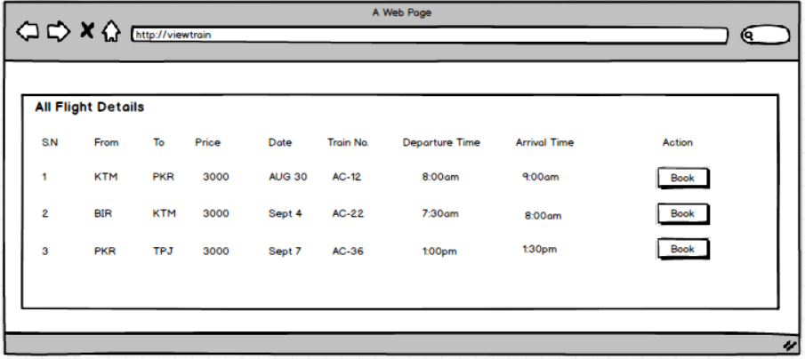
Figure 15: Flight schedule

- Passengers details

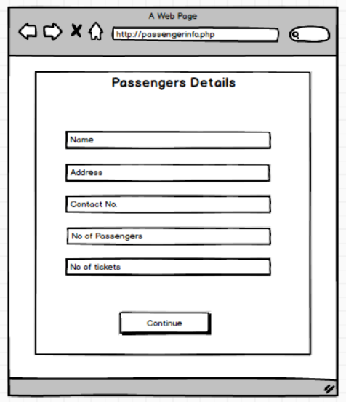

Figure 16: Passengers details

- Payment

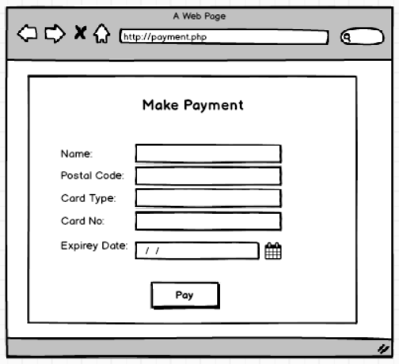
Figure 17: Payment

- Feedback
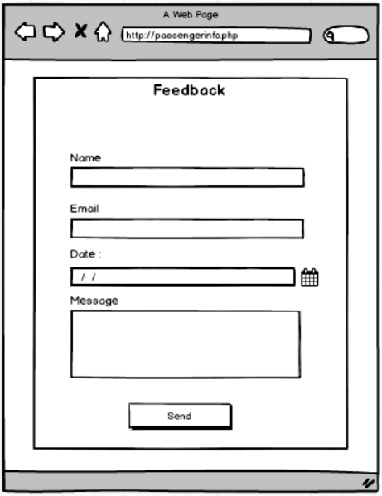
Figure 18: Add Feedback
- Admin login form
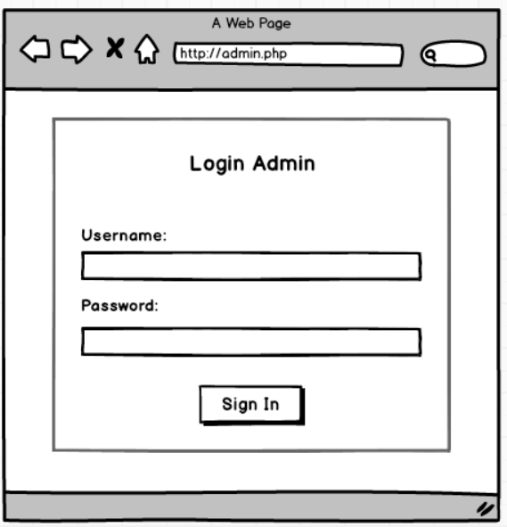
Figure 19: Admin login

- Add flight details in admin panel
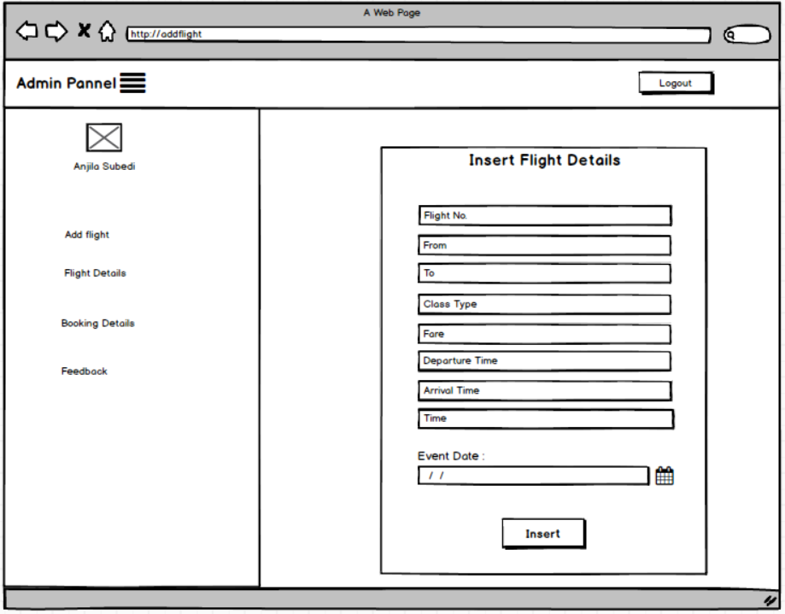
Figure 20: insert flight details

- Update flight details
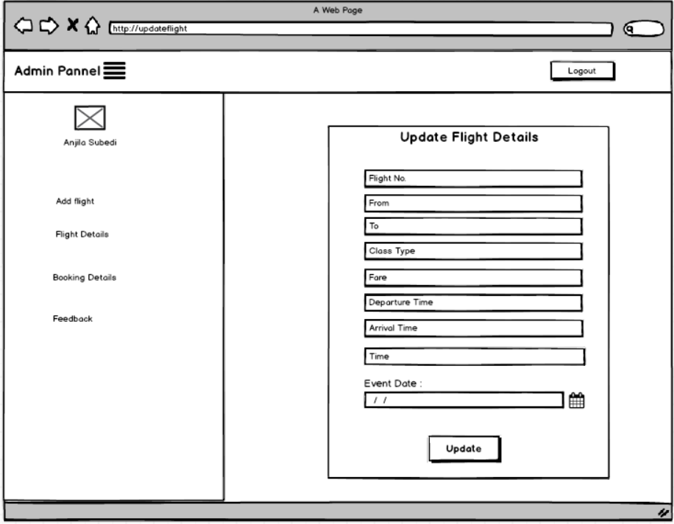
Figure 21: Update flight details

- View flight details
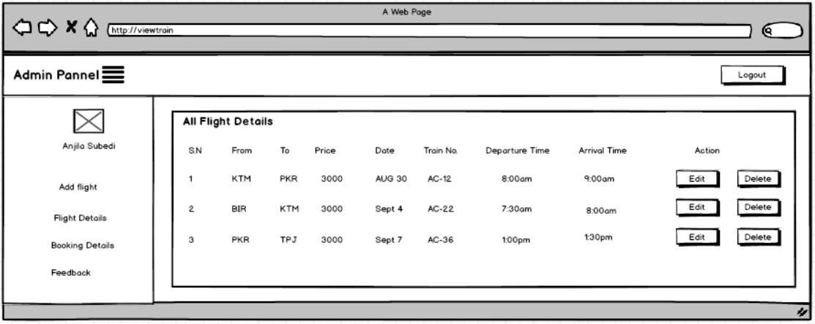
Figure 22: Flight details

- Home page

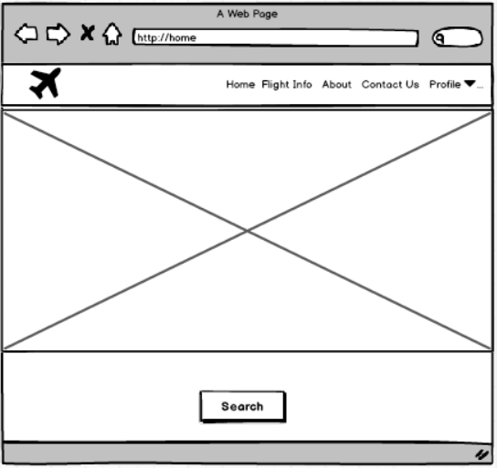
Figure 23: Flight search

